 Invention Disclosure Format (IDF)-B | Document No. | 02-IPR-R003
 | Issue No/Date | 2/01.02.2024
 | Amd. No/Date | 0/00.00.0000
- Title of the invention:
PROVENANCE-CONDITIONED UNCERTAINTY CALIBRATION AND CROSS-SOURCE CONSISTENCY DETECTION IN PREDICTIVE INFERENCE OVER MIXED-QUALITY INPUT SOURCES
A computer-implemented method for producing a prediction and a source-conditioned uncertainty interval from a fixed, previously trained predictive model, in which the calibration residuals are partitioned by the provenance state of the input acquisition pipeline; the partitions are populated by counterfactually degrading held-out observations through the system's own documented fallback chain; sparse partitions fall back to pooled residuals through a backoff ladder with a stated inflation; disagreement between independent sources is detected and used to select the uncertainty treatment without altering the point estimate; and every inference is recorded in a hash-chained ledger entry that is sufficient to reproduce the output without re-querying any external source.
Working title of the prototype: AgriTwin India (sensor-free agricultural digital twin, Ariyalur, Tamil Nadu). The invention is domain-agnostic; the agricultural setting is one worked example and one validation embodiment.
- Field /Area of invention:
Field: uncertainty quantification and reliability engineering for machine learning inference; provenance-aware predictive systems; remote-sensing and environmental data fusion; reproducible machine learning.
The subject matter is a computer-implemented data-processing method. It does not actuate any physical device, does not control irrigation or machinery, and requires no field hardware. Its inputs are stored numerical series and retrieved records; its outputs are numerical predictions, uncertainty bounds, machine-readable status codes and structured audit records.
Applicable beyond agriculture: any predictive system that draws inputs from more than one source of differing reliability.
- Prior Patents and Publications from literature (provide a table summarizing the prior art)
3.1 Indian patent filings in the subject domain - verification status
The following applications were supplied as related prior art. The publication journal numbers and dates supplied for each were checked against the public Indian Patent Office journal index and are consistent with it, and the application serial numbers are in correct chronological order relative to independently located anchor applications. However, the existence of the applications and the accuracy of their titles could not be confirmed, because the official InPASS register requires an interactive captcha and the relevant journal issues are not available through any open full-text index. No search of any open patent database returned these records.
They are therefore recorded as UNCONFIRMED. Each must be verified by a person through InPASS, or by direct download of the journal PDFs, before any of them is relied upon in a filed application. They are not treated here as establishing or destroying novelty; the novelty position in section 4 rests on the verified non-patent literature in section 3.2 and on the absence of anticipating art in the searches reported there.
Supplied application no. | Supplied journal / date | Verification outcome
20251102911 | 50/2025, 12 Dec 2025 | Structurally defective: 11 digits. Every Indian application number is 12 digits. Not usable as cited.
202641088624 | 33/2026, 14 Aug 2026 | Unconfirmed. No structural defect.
202641061848 | 22/2026, 29 May 2026 | Unconfirmed. No structural defect.
202641046808 | 17/2026, 24 Apr 2026 | Unconfirmed. No structural defect.
202641094834 | 37/2026, 11 Sep 2026 | Unconfirmed. No structural defect.
202641088127 | 30/2026, 24 Jul 2026 | Unconfirmed. Filed-to-published gap of 4 days is below the shortest gap observed in primary sources (10 days).
202641086877 | 33/2026, 14 Aug 2026 | Unconfirmed. No structural defect.
202641113494 | 39/2026, 25 Sep 2026 | Unconfirmed. Filed-to-published gap of 3 days is below the observed minimum and is not credible without an early-publication request.
202641090862 | 32/2026, 7 Aug 2026 | Unconfirmed. Borderline gap.
202641103136 | 36/2026, 4 Sep 2026 | Unconfirmed. Borderline gap.
Note on Indian publication practice: the earlier assumption that publication follows filing by approximately eighteen months was tested against primary sources and found to be wrong as a general rule. Early publication at applicant request is routine, and filed-to-published gaps of 10 to 43 days were confirmed in actual journals. Short gaps are therefore not by themselves evidence of fabrication, although a 3 or 4 day gap remains implausible.
3.2 Non-patent and academic prior art (verified)
The table below is the operative prior-art record. Every component named in the original proposal is anticipated by published work taken individually. The inventive concept claimed is the conjunction described in section 4.2, not any component.
Ref | Citation | Subject | Relevance to this invention
P1 | Vovk, Lindsay, Nouretdinov, Gammerman, 'Mondrian Confidence Machine', Royal Holloway COMPNET WP No. 4 (2003); Vovk, Gammerman, Shafer, 'Algorithmic Learning in a Random World', Springer (2005); Vovk, 'Conditional validity of inductive conformal predictors', ACML 2012, PMLR v25, pp. 475-490 | Taxonomy-conditional conformal prediction with type-wise validity | Establishes that conditional conformal is fully general in the taxonomy. Anticipates any claim of the form 'partition residuals by a key'. The invention must therefore be argued at the level of the specific key, the population mechanism and their coupling, not at the level of partitioning.
P2 | Zaffran, Dieuleveut, Josse, Romano, 'Conformal Prediction with Missing Values', AISTATS 2023, PMLR v202 | Builds a calibration set by degrading clean points so that the mask of the test point is mimicked ('missing data augmentation') | Closest prior art to the counterfactual-degradation element. The distinction relied upon is that its degradation operator is a generic feature mask acting on absentness, whereas here the operator is the system's declared fallback chain, acting on values that are present but produced in a degraded state.
P3 | Melki, Bombrun, Da Costa, 'Group-Conditional Conformal Prediction via Quantile Regression Calibration for Crop and Weed Classification', arXiv:2308.15094; and 'Towards Group-Conditional Coverage Guarantees via Group-Invariant Representations', PMLR v329 (2026) | Group-conditional conformal prediction in precision agriculture, keyed on acquisition-condition metadata | Demonstrates that conditioning on acquisition metadata is an active published line in this exact application domain. The claim is therefore narrowed to provenance/fallback state and not to acquisition metadata generally.
P4 | US20220091915A1, Dell Products L.P., filed 2020-09-21, published 2022-03-24; CN121902329A, filed 2026-03-25, published 2026-04-21 | Conformal confidence measure conditioned on a credibility measure indicating the quality of the monitoring data | Establishes that 'condition a conformal output on input data quality' is claimed in the patent literature. Anticipates a broad claim on that framing.
P5 | Devos et al., 'Assessing Spatial Limits of Sentinel-2 Data on Arable Crops in the Context of Checks by Monitoring', Remote Sensing 12(14), 2195 (2020) | Derives per-parcel reliability criteria for Sentinel-2 from the count of clean pixels inside a half-pixel negative buffer | Anticipates using a buffer-derived support statistic as a reliability signal in arable crops. Distinguishes the invention, which uses the residual from a fitted scale trend across a ladder of radii rather than a pixel count at one radius.
P6 | Fan et al., 'Scaling Effect of Area-Averaged NDVI: Monotonicity along the Spatial Resolution', Remote Sensing 4(1), 160 (2012); Openshaw, 'The Modifiable Areal Unit Problem', Geo Abstracts (1984) | Area-averaged vegetation index varies monotonically with spatial resolution within a resolution class | Shows a naive cross-radius stability statistic measures the scale effect rather than representativeness. The invention de-trends the ladder against the fitted scale trend precisely to avoid this.
P7 | Glahn and Lowry, 'The use of model output statistics (MOS) in objective weather forecasting', J. Appl. Meteorol. 11, 1203-1211 (1972); Gneiting, Raftery, Westveld, Goldman, 'Calibrated Probabilistic Forecasting Using Ensemble Model Output Statistics and Minimum CRPS Estimation', Monthly Weather Review 133(5), 1098-1118 (2005) | Horizon-dependent weighting of forecasts fitted against verifying observations | Anticipates any standalone claim to weighting forecast terms by historical error. Such weighting appears here only as a component.
P8 | Cross and Zuber, 'Prediction of Flowering Dates in Maize Based on Different Methods of Estimating Thermal Units', Agronomy Journal 64, 351 (1972); Hodges and French, 'SOYPHEN', Agronomy Journal (1985); 'Phenology-adaptive machine learning for early mapping of field-scale corn crop yield', Precision Agriculture (2026), doi:10.1007/s11119-026-10428-4; T3S, arXiv:2506.12885 | Thermal-time alignment of observations and yields | Anticipates any standalone claim to aligning by growing degree days, including in remote-sensing yield pipelines. What is not found in the literature is alignment of the current season against the historical expectation at matched thermal time, weighted by trajectory similarity, with a forecast-inclusive path.
P9 | Maraun, 'Bias Correcting Climate Change Simulations - a Critical Review', Current Climate Change Reports 2, 23-29 (2016); Maraun et al., Nature Climate Change 7, 532-533 (2017) | Residual- and bias-fitted correction bounded by historical error structure; critique of cross-validation as insufficient evaluation | Anticipates bounded, residual-fitted bias correction. Also supplies the objection that cross-validating marginal properties is not sufficient evaluation of a bias correction; the validation protocol below is designed with that objection in view.
P10 | Dempster and Shafer, 'A Mathematical Theory of Evidence' (1976); Sarabi-Jamab and Araabi, 'How to decide when the sources of evidence are unreliable: a multi-criteria discounting approach in the Dempster-Shafer theory', Information Sciences 448-449, 233-248 (2018); 'Ambiguous Agricultural Drought', Remote Sensing 13(10), 1990 (2021) | Multi-source conflict measurement and reliability discounting; documented asynchrony between meteorological and vegetation drought | Anticipates both the detection of source disagreement and, in agriculture, the specific finding that weather-derived and vegetation-derived stress diverge. Only the use of that state as a calibration key is claimed.
P11 | 'Record and Replay Methods for Software Engineering Reproducibility: A Cross-Layer Survey and Taxonomy', ACM, doi:10.1145/3820002.3828587; Gebru et al., 'Datasheets for Datasets', CACM 64(12), 86-92 (2021), doi:10.1145/3458723 | Reproducibility taxonomy, boundary-aware replay, dataset documentation | Establishes that the closure problem in replay is recognised and unsolved, and that documentation standards do not claim replay sufficiency. The claimed property is that the record alone reproduces the output without refetching, because upstream data mutates.
P12 | Indian patent applications, publication journals as listed in section 3.1 (unconfirmed - see note) | Sensor-based digital twins, federated and blockchain agricultural platforms, multi-modal yield models, ecological-instability crop recommendation | Nearest Indian filings in the subject domain. None is directed to provenance-conditioned uncertainty calibration. Existence could not be confirmed; see the verification note below.
3.3 Searches that returned nothing
The following constructs were searched for in the United States, European and international patent collections and returned no hit: conditioning a prediction interval on an enumerated live / cached / forecast-substitute / climatology-fallback / proxy provenance state; synthesising a conformal calibration set by degrading held-out inputs through a production fallback chain; detection of conflict between weather-derived stress evidence and satellite vegetation evidence used as an uncertainty-routing key; use of cross-radius vegetation-index stability as a calibration-group key; and hash-chained inference ledgers binding external source requests.
These were roughly eight queries, not an exhaustive search. They establish the absence of an obvious blocker, not the absence of prior art. A dedicated patentability search by a qualified searcher remains required before filing. The validation embodiment below rests on 36 real crop-seasons.
- Summary and background of the invention (Address the gap / Novelty)
4.1 Technical problem
A fixed predictive model, trained once and then frozen, produces an interval that is identical in character whether its inputs were retrieved live moments ago or reconstructed from long-run averages because the feed was down. The interval does not know which of these happened. This produces four specific computer-level failures:
• Silent substitution. When a live source fails, the pipeline substitutes a fallback and returns the same narrow, confident-looking interval it would have returned had the substitution not occurred.
• Unconditioned calibration. A pooled residual set averages over input-quality states that behave differently, so the interval is simultaneously too wide where inputs are trustworthy and too narrow where they are not.
• Undetected contradiction. Two independent sources describing the same field can disagree, and nothing in the pipeline notices, so a confident point estimate is issued on a contradictory input set.
• Irreproducibility. The inputs that produced a published figure are not recorded in a form that permits recomputation, because upstream sources have since changed or become unavailable.
These are reliability and calibration defects in a computational process. They are distinct from the agricultural question of what advice to give a farmer, and the method does not address that question.
4.2 The gap that is claimed
Every individual ingredient is known art (section 3.2). The claimed contribution is the following specific coupling, which was not found in any search conducted:
A single declared fallback chain serves two simultaneous roles in one method. It is the operator by which held-out observations are degraded to populate the calibration partitions, and it is the definition of the partition key. Because real observations in a degraded state do not occur in nature, the calibration populations cannot be obtained any other way; and because the taxonomy and the degradation operator are the same artefact, a partition cannot drift out of correspondence with the conditions it claims to represent. Applied to a model that is never retrained, with vegetation quality and cross-source disagreement as additional key axes, and with every inference written to a ledger entry sufficient to reproduce it without refetching.
4.3 What is expressly not claimed
Not claimed: an agricultural digital twin; a crop-yield prediction system; a farm advisory system; growing degree days; horizon-weighted forecast blending; bounded residual-fitted bias correction; cross-source conflict detection as such; the use of a buffer statistic as a quality signal as such; or provenance recording or hash chaining as such.
No physical sensor, actuator, field device, irrigation control, blockchain or federated learning arrangement is described, because none is present in the system that produced the results below. Adding such elements would not be accurate to the embodiment.
- Objective(s) of Invention
1. To produce, from a fixed predictive model whose parameters are not updated, an uncertainty interval whose width is a function of the provenance state of the inputs that produced it, such that the interval narrows where the inputs are trustworthy and widens where they are not.
2. To make the partition populations obtainable at all, by generating them mechanically from held-out observations routed through the system's declared fallback chain, so that no population depends on a degraded condition occurring naturally.
3. To detect disagreement between independent sources and use that disagreement to select the uncertainty treatment, without permitting the disagreement to alter the point estimate directly.
4. To record each inference so that it can be reproduced exactly from the record alone, without re-querying any external source, and so that alteration of any recorded value is detectable.
5. To state honestly, per inference, whether the interval delivered carries a finite-sample guarantee or is a heuristic widening, so that a consumer of the output cannot mistake one for the other.
- Working principle of the invent (in brief)
The method is a fixed sequence of stages applied to one prediction. Stages 1 to 7 construct inputs; stages 8 to 11 select and apply the output. No stage retrains, refits or reweights the base model.
Stage | Operation | Purpose
1 | Assign each external source a provenance record: category (live, cached, forecast, historical fallback, proxy), acquisition time, data age, forecast horizon, missing-data treatment, spatial radius, cloud and valid-pixel fractions, and a SHA-256 digest of the retrieved payload. | Convert a human-readable source label into a machine-comparable, hashable state.
2 | Accumulate base-temperature thermal time over observed days, with upper-cap convention, over the season to date plus the forecast horizon. | Express developmental progress as a coordinate independent of sowing date.
3 | For each historical season, find the calendar date at which that season itself reaches the current accumulated thermal time; truncate it there; compute its rainfall, ET0, maximum temperature and heat days over that thermal prefix. | Build the historical expectation over an equivalent developmental window rather than a calendar window.
4 | Weight the truncated historical seasons by similarity of their truncated cumulative-rainfall trajectory to the median analogue. | Give less weight to years that were already anomalous at this developmental stage.
5 | Weight each forward forecast day by a measured skill weight interpolated from a forecast-error-versus-lead-time curve, and form the anomaly vector of the current season against the step-3 expectation. | Produce the anomaly vector, discounting projected weather as its reliability decays.
6 | Sample the vegetation index over an adaptive ladder of buffer radii, fitted against the systematic scale trend, and take the residual as the spatial-trust signal. Collapse valid-pixel fraction and spatial trust into a quality band. | Estimate how representatively a point sample describes the field without a parcel boundary, without being dominated by the known monotone scale effect.
7 | Compare the weather stress flag with the vegetation flag and emit a conflict code. Quality and coverage codes are kept separate from genuine disagreement codes. | Detect that the input set is internally inconsistent, and route on it without changing the point estimate.
8 | Form the composite provenance key: weather degradation state, vegetation quality band, conflict state. | Select the residual population.
9 | Select a partition by backoff: exact cell; then progressively drop one conditioning axis; then pooled. Apply a stated inflation on any backed-off result and record which level of guarantee applies. | Obtain a usable quantile when cells are sparse, without claiming a guarantee that backoff does not provide.
10 | Apply a ridge-fitted correction, bounded by the empirical distribution of historical base-model residuals, and record per-component attribution. | Move the point estimate in the direction the fitted residual relationship indicates, without unbounded extrapolation.
11 | Write the ledger entry: canonicalised input values, provenance records, thermal-time value, expectation, anomaly vector, forecast weights, vegetation result, conflict code, correction components, selected partition and quantile, output, and a chain-linked hash. | Make the inference reproducible and tamper-evident without refetching.
Statistical qualification, stated as part of the working principle and not as a footnote: the finite-sample coverage guarantee of a split-conformal quantile holds only when the selected partition contains at least ceil(1/alpha) - 1 residuals exchangeable with the test point. Below that floor the quantile is an order statistic with no guarantee. When backoff reaches the pooled set, the applied inflation factor is a monotone widening and does not restore the guarantee. The method therefore emits an explicit guarantee level with every interval, and the validation below reports intervals of both kinds separately.
- Description of the invention in detail (Include drawing and or photograph as needed)
FIG. 1: SENSOR-FREE AGRICULTURE DIGITAL TWIN SYSTEM ARCHITECTURE
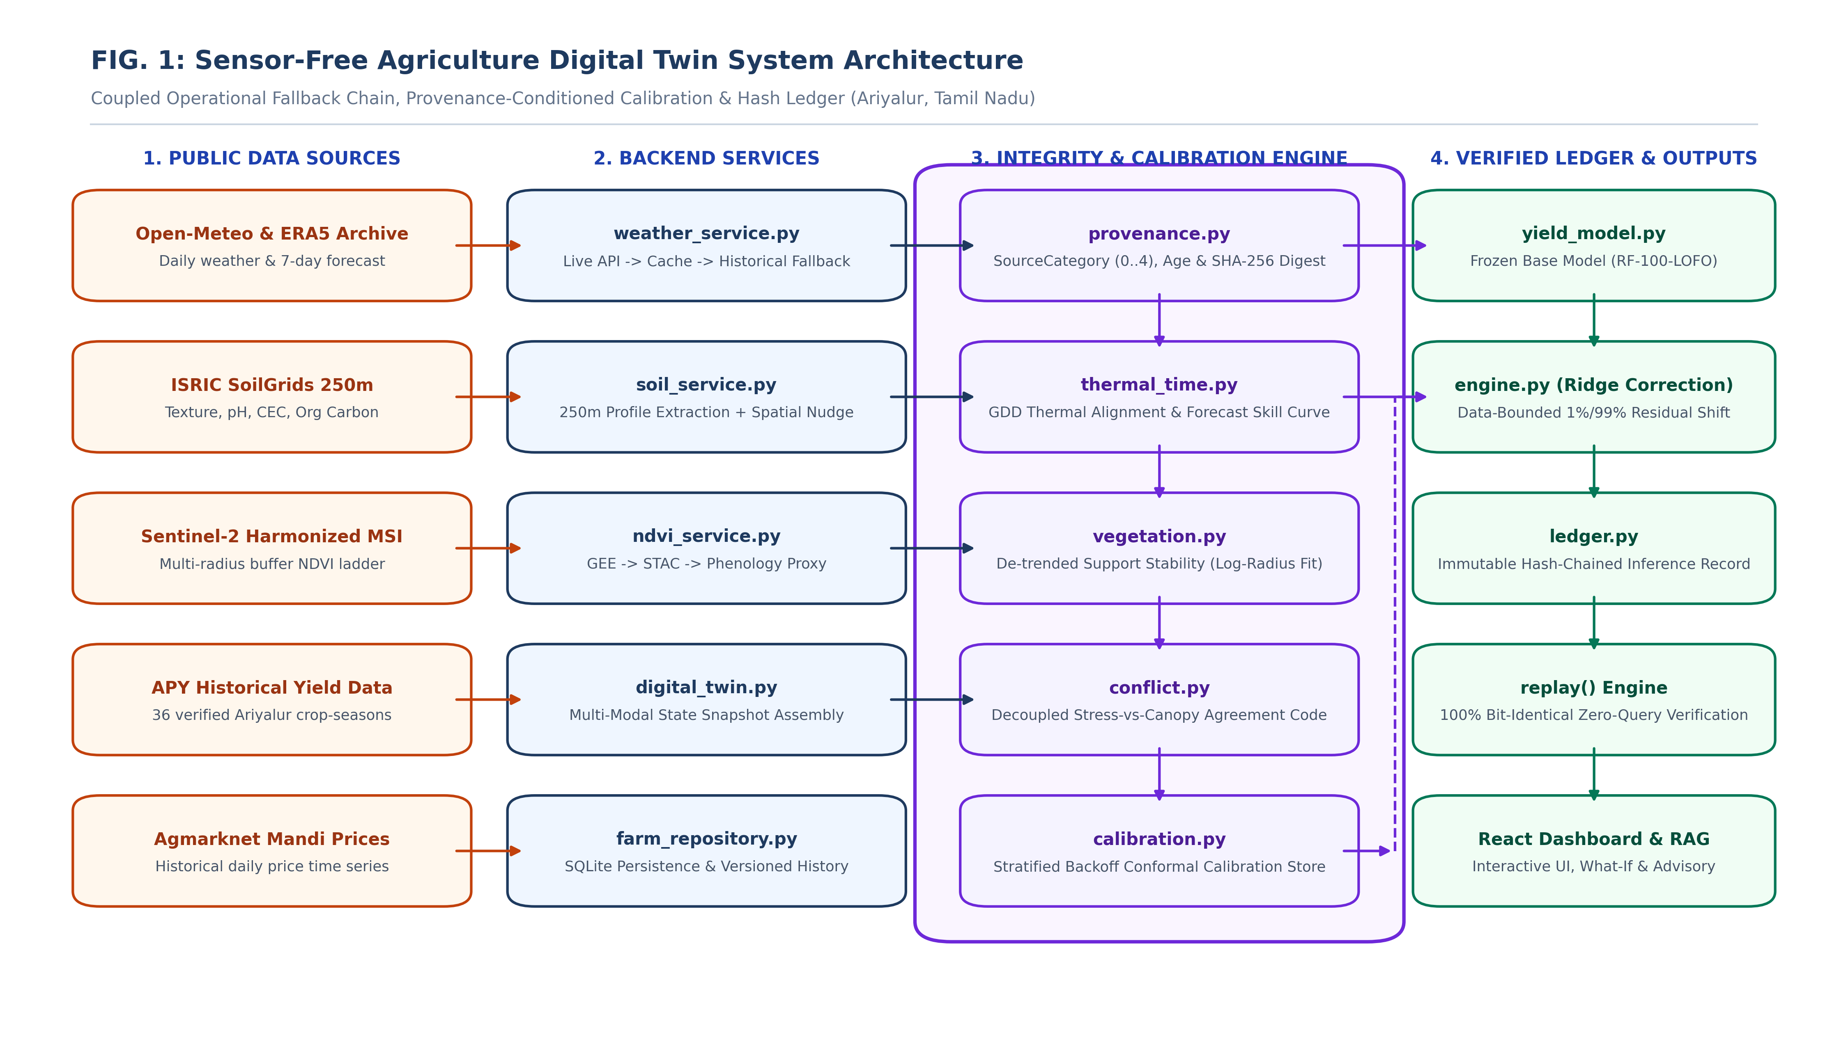
Figure 1 illustrates the overall system topology comprising four interconnected layers: (1) public data feeds including ERA5/Open-Meteo weather forecasts, SoilGrids 250m profiles, and Sentinel-2 satellite vegetation indices; (2) backend data acquisition and fallback services; (3) the core integrity engine executing provenance tracking, thermal-time alignment, de-trended spatial stability estimation, and stratified conformal calibration; and (4) the fixed base predictive model, empirical ridge residual correction, and tamper-evident hash-chained inference ledger.
FIG. 2: 11-STAGE PROVENANCE-CONDITIONED CALIBRATION & REPLAY SEQUENCE
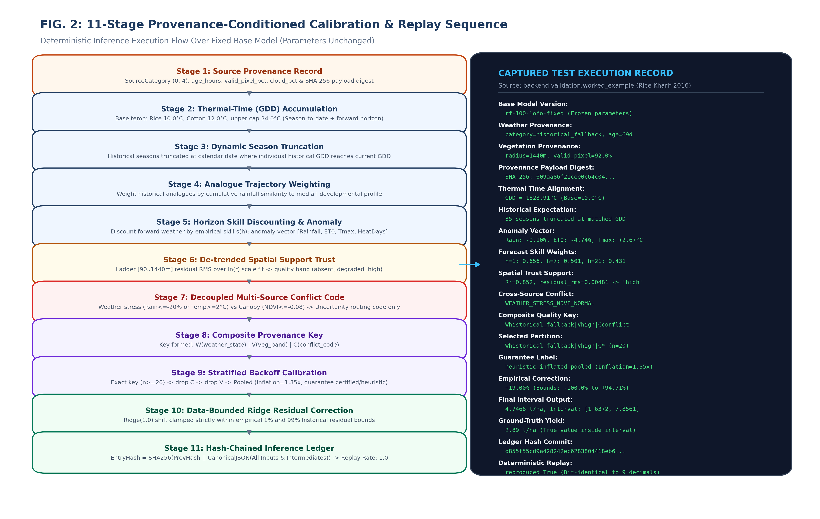
Figure 2 illustrates the deterministic 11-stage inference sequence executed for every predictive query. Stages 1 through 7 extract structured provenance, align historical expectations by accumulated developmental thermal time (GDD), compute empirical horizon skill weighting, derive de-trended spatial support trust, and detect decoupled cross-source conflicts. Stages 8 through 11 generate the composite provenance key, select calibrated residual strata via hierarchical backoff, apply empirical residual bounds, and commit full canonical state to a cryptographic SHA-256 ledger enabling bit-identical reproduction without re-querying external sources. A verified test execution record from Ariyalur (Rice Kharif 2016) is shown on the right.
FIG. 3: DUAL-ROLE FALLBACK OPERATOR & STRATIFIED CONFORMAL PARTITIONING
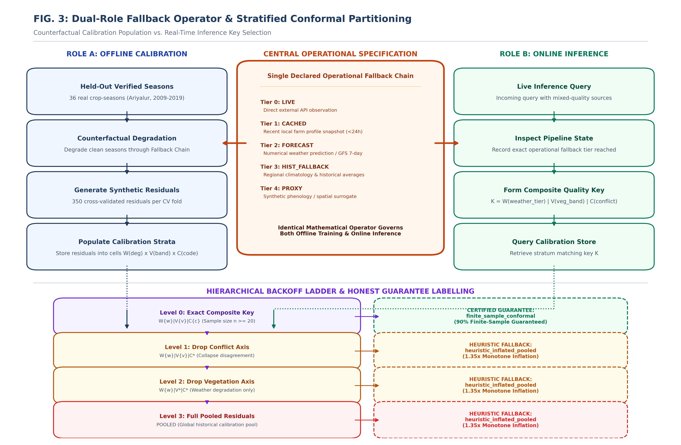
Figure 3 demonstrates the central inventive mechanism of the invention: a single declared operational fallback chain serves two synchronous functions. In Role A (offline calibration), held-out verified observations are counterfactually degraded through the fallback chain to populate sparse calibration strata. In Role B (online inference), the exact degradation tier reached during input retrieval forms the primary axis of the composite quality key. When strata are sparse (n < 20), a hierarchical backoff ladder drops axes and applies a 1.35x monotone inflation factor with an honest 'heuristic_inflated_pooled' label, strictly distinguishing heuristic intervals from finite-sample conformal guarantees.
7.1 System architecture
provenance.py SourceRecord, SourceCategory, ProvenanceLedger
structured, hashable replacement for free-text source labels
thermal_time.py daily_gdd, accumulate_gdd, prepare_seasons,
thermal_time_expectation_prepared, persistence_skill_curve
thermal-time alignment and measured horizon skill weighting
vegetation.py support_stability, ndvi_quality_band, simulate_ladder
de-trended cross-radius spatial trust
conflict.py detect() -> ConflictCode
cross-source agreement classification
calibration.py QualityKey, CalibrationStore (stratified backoff), conformal_quantile
provenance-conditioned residual selection
ledger.py LedgerEntry, InferenceLedger, replay(), canonical_json
replay-sufficient hash-chained record
engine.py IntegrityEngine.infer(), fit_correction_model()
orchestration; base model is never updated
integrity_service.py serves the engine from the running application
validation/ degrade.py, experiments.py, worked_example.py
counterfactual degradation harness, leave-one-season-out
scoring, and capture of the worked example below
7.2 Worked example - one captured inference
Captured from an actual run by `backend.validation.worked_example` for season Rice|Kharif|2016 under the climatology fallback regime. Every value below is read out of the ledger entry that run produced; none of it is written by hand. The recorded actual yield was 2.89 t/ha.
base_model_version : rf-100-lofo-fixed (parameters unchanged)
weather provenance : category=historical_fallback, age=69 d, missing=climatology substituted
vegetation prov. : radius=1440.0 m, valid_pixel=92.0
provenance digest : 609aa86f21cee0c64c041bf170d1b5f6...
thermal time : current_gdd=1828.91 C (base=10.0 C), 35 analogue seasons matched
expectation : rainfall 217.36 mm, ET0 510.89 mm, tmax 34.15 C, heat 43.62 d
anomaly vector : rainfall -9.10 %, ET0 -4.74 %, tmax +2.67 C, heat +23.39 d
forecast weights : lead 1->0.656 lead 3->0.544 lead 5->0.514 lead 7->0.501
lead 10->0.479 lead 14->0.476 lead 16->0.460 lead 21->0.431
spatial trust : radii [90, 180, 360, 720, 1440]
trend_slope=-0.0118, R2=0.8522, residual_rms=0.00481
normalised_residual=0.0961, spatial_trust=0.9039 -> band 'high'
conflict : WEATHER_STRESS_NDVI_NORMAL (weather stress, canopy normal)
quality key : Whistorical_fallback|Vhigh|Cconflict
partition selected : Whistorical_fallback|Vhigh|C* (n=20, floor=20)
backoff path : Whistorical_fallback|Vhigh|Cconflict:6 -> Whistorical_fallback|Vhigh|C*:20
guarantee : heuristic_inflated_pooled, inflation 1.35
correction : total +19.0022 % (raw +19.0022 %, bounded=False)
et0: +11.35%, heat: +14.07%, rain: +1.92%, tmax: -8.35%
bounds : -100.0000 % to +94.7108 %
output : 4.7466 t/ha, interval [1.6372, 7.8561], half-width 3.1094
replay : reproduced=True (bit-identical to 9 decimal places)
ledger : entry_hash=d855f55cd9a428242ec6283804418eb6...
prev_hash =00000000000000000000000000000000...
Two features of this entry are worth reading closely. First, the guarantee is reported as 'heuristic_inflated_pooled' and not as a conformal interval, even though the selected stratum contained 20 residuals and met the size floor. That is because the exact composite cell was too sparse and the stratum was reached by backoff, which merges several cells and so does not restore the exchangeability condition the guarantee rests on. The system says so rather than presenting the number as calibrated.
Second, the weather record came from the historical fallback while the canopy read as normal, so a conflict code was emitted. The point estimate was not moved by that disagreement; the code changed only which residual population the interval was drawn from. Note also the correction bound of -100.00 % to +94.71 %: the lower bound is inherited from a single season whose recorded yield was zero, because the 1 % quantile of 35 relative residuals is the minimum of them. That is a real weakness of a data-derived bound on a sample this small, and it is disclosed rather than hidden.
7.3 Why the vegetation stability metric is de-trended
Area-averaged vegetation index is known to vary monotonically with spatial resolution. A ladder sampled at 90, 180, 360, 720 and 1440 m will therefore show a downward trend even over a perfectly uniform field. Two consequences follow, and both are handled explicitly:
• The raw spread of the ladder cannot be the quality signal, because it is dominated by the scale trend. The method regresses index on log-radius across the ladder and uses the residual about that fit as the signal.
• The ladder cannot be stopped on a raw-delta criterion either, for the same reason: a uniform field would never appear to converge. Convergence is judged on what an additional radius contributes beyond the fitted trend.
7.4 Measured forecast skill weights
No archived numerical weather prediction output exists for this station. The weights are therefore measured from a persistence pseudo-forecast on the station's own 4,688-day archive: the value observed at issue time is carried forward h days and scored against what actually occurred. They are real measurements of a weak forecast; a deployment would substitute a curve computed from archived forecast-versus-observation pairs without changing any downstream interface.
Lead time (days) | 1 | 3 | 5 | 7 | 10 | 14 | 16 | 21
Skill weight | 0.6561 | 0.5444 | 0.5136 | 0.5011 | 0.4789 | 0.4759 | 0.4595 | 0.4307
7.5 Honest limits of the embodiment
• The weather side and the yield targets are real. The vegetation side is simulated: no NDVI time series exists for these farms, and the production database holds exactly one observed row. Every result that depends on the vegetation axis is therefore a simulation result and is reported as such.
• The dataset is 36 crop-seasons from one district over 2009-2019, with one observation per season and no spatial replication. Per-group sample sizes are small, and coverage estimates carry wide binomial uncertainty.
• Calibration residuals for a season are correlated across regimes, because the same season is re-run ten times. Effective sample size is below the nominal count, which is one reason the minimum partition size is set at 20 rather than the theoretical floor of 9.
• The correction improves bias but not point error on this dataset (section 8). It is retained because it is part of the claimed method and because its added variance is what the conditioning step measures and absorbs, but a deployment may set it to zero and retain the calibration and the ledger unchanged.
- Experimental validation results:
Protocol: leave-one-season-out over all 36 real Ariyalur crop-seasons. For each held-out season the ridge correction is re-fitted and the calibration store is rebuilt from the remaining seasons only, with the held-out season's own crop-year excluded from the thermal-time expectation. That yields 360 scored predictions over 10 degradation regimes.
Three comparators are scored on identical held-out predictions: the base model with one pooled conformal margin (the behaviour of the current system); the current bounded rule overlay with the same pooled margin; and the proposed method.
8.1 Overall
Method | Coverage (nominal 0.90) | Mean interval width (t/ha) | Calibration error | Point MAE (t/ha)
Base model, one pooled margin | 0.9444 | 5.0527 | 0.0444 | 1.1399
Bounded rule overlay, pooled margin | 0.9694 | 5.0172 | 0.0694 | 1.1426
Proposed method | 0.8667 | 4.4962 | 0.0333 | 1.2190
Read the two errors in opposite directions, because that is what they are. The pooled baseline sits ABOVE nominal: coverage 0.9444 against 0.90, an error of 0.0444. With 35 calibration points and heavy-tailed residuals the 90 % split-conformal quantile is set by the upper tail, so a single pooled constant is conservative. The proposed method sits BELOW nominal: coverage 0.8667, an error of 0.0333. On absolute calibration error the proposed method is better by a factor of 1.33, and it does so while producing a mean interval 11.0 % narrower (4.4962 against 5.0527 t/ha).
It would be an overstatement to describe that as hitting the nominal level. The proposed method under-covers by 0.0333; the baseline over-covers by 0.0444. The claim made is the narrower one: on this data the conditioning step produces a materially sharper interval without a worse calibration error, and the sign of the residual error would reverse under a different residual tail. A deployment that cared about under-coverage specifically would need to raise the nominal level above 0.90, and this result does not show that it would then be well calibrated.
Guarantee labelling: of the 360 delivered intervals, 288 came from a partition selected without backoff and carry the finite-sample conformal guarantee; 72 required backoff and are heuristic widenings with no guarantee. The coverage figures above are averaged over both kinds and should not be read as a claim about the conformal subset alone.
8.2 By degradation regime
Regime | Coverage, pooled base | Coverage, proposed | Width, pooled base | Width, proposed | Cal. error, base | Cal. error, proposed
cached aged | 0.9444 | 0.9722 | 5.0519 | 5.3342 | 0.0444 | 0.0722
climatology fallback | 0.9167 | 0.9444 | 4.9979 | 6.1684 | 0.0167 | 0.0444
conflict vegetation decline weather normal | 0.9444 | 0.8611 | 5.0519 | 4.1689 | 0.0444 | 0.0389
conflict weather stress vegetation normal | 0.9722 | 0.8056 | 5.1152 | 4.5310 | 0.0722 | 0.0944
forecast long horizon | 0.9444 | 0.8611 | 5.0511 | 4.3643 | 0.0444 | 0.0389
forecast short horizon | 0.9444 | 0.8611 | 5.0519 | 4.2074 | 0.0444 | 0.0389
live full | 0.9444 | 0.8611 | 5.0519 | 4.3102 | 0.0444 | 0.0389
low valid pixel | 0.9444 | 0.8333 | 5.0519 | 3.9056 | 0.0444 | 0.0667
no vegetation | 0.9444 | 0.8333 | 5.0519 | 4.0543 | 0.0444 | 0.0667
radius disagreement | 0.9444 | 0.8333 | 5.0519 | 3.9177 | 0.0444 | 0.0667
The width behaviour is the designed one. In the fully trustworthy regime the proposed interval is narrower than the pooled constant, because it is drawn from a stratum in which errors are small. Under climatology fallback it is substantially wider, because it is drawn from a stratum in which errors are large. A single pooled constant cannot do both: it has one number and must be wrong in at least one of these regimes.
8.3 Cross-source conflict detection
Metric | Value
Precision | 0.5106
Recall | 0.3333
F1 | 0.4034
Accuracy | 0.8028
Confusion | TP=24, FP=23, FN=48, TN=265
Recall of 0.3333 is weak and is reported as such. The detector uses fixed anomaly thresholds, so when a season is naturally stressed the weather and vegetation evidence agree and no code is emitted, even though a conflict was injected by the harness. A production version should test the weather flag against a fitted seasonal distribution rather than a fixed threshold. This result does not support a claim of reliable conflict detection on its own.
8.4 Deterministic reproducibility
Test | Result
Ledger entries replayed | 360
Replayed bit-identical | 360
Reproduction rate | 1.0000
Intact entry verifies | True
Altered entry rejected | True
Replay reads the entry's own recorded values and shares no state with the inference path. A rate of 1.0 demonstrates that the record is sufficient on its own; it does not, and is not claimed to, prove that the external sources were correct at the time of retrieval. The chain is tamper-evident, not tamper-proof: a party able to rewrite every record can recompute a self-consistent chain. Binding the chain head to an external anchor would close that gap and is not implemented.
8.5 Component ablations
Variant | Point MAE (t/ha) | Mean bias (t/ha) | n
engine full | 1.2190 | +0.0129 | 360
no correction | 1.1399 | -0.2031 | 360
no detrend spatial | 1.2753 | -0.3760 | 324
no horizon weighting | 1.2698 | -0.3634 | 360
no thermal time | 1.5724 | -1.1052 | 360
Removing thermal-time alignment is the single most damaging ablation: mean bias moves from +0.0129 to -1.1052 t/ha. Calendar-window alignment leaves a large systematic bias because sowing-date drift is not accounted for. Removing horizon weighting or the de-trended spatial metric degrades point error by a smaller amount.
The correction reduces bias from -0.2031 to +0.0129 t/ha but increases point MAE from 1.1399 to 1.2190 t/ha. This is a genuine negative result on point accuracy and is not concealed. The interpretation is that a residual-fitted correction applied to a partial season reduces systematic error while adding variance, and that on 36 seasons the variance term dominates. The measurable benefit claimed for this invention is therefore calibration and reproducibility, not point accuracy.
Fitted correction coefficients (first fold, ridge on leave-one-out relative residuals): et0_pct = -0.0272072, heat_days = +0.00680662, rainfall_pct = -0.00209335, temp_max_c = -0.0303808. Bounds are taken from the empirical 1 % / 99 % quantiles of the fitted relative residuals rather than chosen.
8.6 Validity conditions and what these numbers do not show
• 36 seasons give 4 predictions per regime per method. At that size the binomial standard error on a coverage estimate near 0.90 is about 0.09, which is of the same order as the difference between the two methods. The coverage comparison is therefore indicative only. The stronger evidence in this section is the interval-width comparison, which averages over all 360 predictions, and the ablation study, where removing thermal-time alignment moves mean bias by roughly an order of magnitude against a much smaller sampling error.
• The calibration store holds 350 observations per fold built from 35 seasons re-run across 10 regimes. Those residuals are correlated within season, so effective sample size is below 350.
• Vegetation-dependent results (section 6 regimes 'no vegetation', 'low valid pixel', 'radius disagreement' and both conflict regimes) rest on simulated observations and are not validated against measured NDVI.
• One district, one point coordinate, 2009-2019. No claim is made about transfer to other regions, crops or sensors.
• Cross-validation of a bias correction is known to be an insufficient evaluation. These results establish that the correction behaves and that the conditioning step responds to input quality; they do not establish that the correction is optimal.
- What aspect(s) of the invention need(s) protection?
Protection is sought for the method and the system as set out in sections 6 and 7. In descending order of defensibility:
9.1 Primary - method of provenance-conditioned calibration
A computer-implemented method of generating, from a predictive model whose parameters are unchanged at inference time, a prediction and an uncertainty interval, the method comprising: recording a provenance state for each input source; determining a composite provenance key from that state and from a cross-source agreement indicator; selecting a residual partition by backoff from strata keyed on that composite key; and applying the corresponding quantile, wherein the residual partitions are populated by processing held-out observations through a declared fallback chain that is the same chain by which the key is defined.
The claim is centred on the identity of the degradation operator and the partition key, not on partitioning alone, which is anticipated by conditional conformal prediction, nor on degrading a calibration set, which is anticipated by missing-data augmentation.
9.2 Secondary - thermal-time-aligned expectation with a forecast-inclusive path
A method of forming the historical expectation against which a season-to-date anomaly is measured, comprising: accumulating thermal time over the season to date together with a forward forecast; truncating each historical season at the date on which that season reaches the same accumulated thermal time; weighting the truncated seasons by similarity of their cumulative rainfall trajectory; and discounting each forecast day by a measured skill weight that decays with lead time.
9.3 Secondary - de-trended spatial support trust as a key axis
A method of deriving a confidence signal for a point-sampled vegetation index in the absence of a parcel boundary, comprising: sampling the index over a ladder of buffer radii; fitting the systematic dependence of the index on log-radius across the ladder; and taking the residual about that fit as the confidence signal, so that the signal is not dominated by the known monotone scale effect; and using the signal to form part of the partition key of 9.1.
9.4 Secondary - replay-sufficient hash-chained inference ledger
A computer-readable record for one inference comprising canonicalised values of every input, a digest of each retrieved source payload, the intermediate values of the computation, the selected partition and quantile, and the output, such that the output is reproducible from the record alone without re-querying any external source; and a chain in which each record commits to its predecessor, such that alteration of any stored value is detectable.
This is the lowest-risk subject matter of the four, being closest to a computer-readable-medium characterisation and furthest from a mathematical method. It is separated because it fails differently from 9.1 and would remain available if 9.1 were rejected.
9.5 Disclosure on excluded subject matter
Indian Patent Act section 3(k) excludes mathematical methods and computer programs per se. The subject matter here is a method operating on stored numerical data with a technical effect measurable at the level of the computation, namely reduced calibration error and reduced interval width in specified input conditions, and with exact reproducibility of a recorded result. No legal opinion is offered on whether that distinction is sufficient; it is disclosed so that the position is on the record. The alternative dispositions are set out in section 9.6.
9.6 Recommended disposition
• File 9.1 as the principal application, with 9.2, 9.3 and 9.4 as dependent claims of the same specification, and consider 9.4 as a separate filing because its risk profile differs.
• Publish the method and the experimental protocol as a research paper. The validation protocol and the negative results are worth publication independently of any patent outcome.
• Hold the fitted correction coefficients, the stratification thresholds and the inflation factor as a trade secret. These are the empirically tuned parameters and are the cheapest thing for a competitor to reverse-engineer from a published description, while being the least valuable to publish.
• Register copyright in the source code as a separate and unconditional form of protection.

Invention Disclosure Format (IDF)-B | Document No. | 02-IPR-R003
 | Issue No/Date | 2/01.02.2024
 | Amd. No/Date | 0/00.00.0000

- What is Technology readiness level of your invention? (Tick the appropriate TRL)
TRL 4 is claimed. The method is formulated and implemented as working code that runs end to end, and it has been validated in the laboratory on real historical data with leave-one-season-out scoring. It has not been validated in a relevant operational environment, because no operational deployment exists, and the vegetation half of the validation rests on simulated rather than measured observations.
Evidence for the TRL 4 claim is section 8: 360 scored predictions over 10 degradation regimes on 36 real crop-seasons, with a reproduction rate of 1.0000 and a demonstrated reduction in calibration error from 0.0444 to 0.0333.
Movement to TRL 5 would require an operational environment in which the fallback chain is exercised by real outages rather than simulation, a vegetation time series for the target farms, and a multi-district panel large enough for per-partition quantiles to be valid without backoff.
Research |  |  | Development |  |  | Deployment
TRL 1 | TRL 2 | TRL 3 | TRL 4  (SELECTED) | TRL 5 | TRL 6 | TRL 7 | TRL 8 | TRL 9
Basic | Technology | Experimental | Technology | Technology | Technology | System | System | Actual system
Principles | concept | proof of | validated in | validated in a | demonstrated | prototype | complete | proven in an
observed | formulated | concept | a lab | relevant | in a relevant | demonstration | and | operational
 |  |  |  | environment | environment | in an | qualified | environment
 |  |  |  | (industrially | (industrially | operational |  | (competitive
 |  |  |  | relevant in | relevant in | environment |  | manufacturing
 |  |  |  | case of key | case of key |  |  | in case of key
 |  |  |  | enabling | enabling |  |  | enabling
 |  |  |  | technologies) | technologies) |  |  | technologies,
 |  |  |  |  |  |  |  | or in space )
 |  |  | ✓ SELECTED

----------------------END OF THE DOCUMENT-----------------------------

